INVITATION LETTER

Subject: Invitation to Attend TEA Industry Event in Dallas, May 27-31, 2025
Dear Sir/Madam,
I am writing to invite Attendee’s Full Name, Job Title at Company Name, to attend the Themed Entertainment Association (TEA) Industry Event in Dallas, Texas, from May 27 to May 31, 2025.
Attendee’s Full Name has been invited to participate in this important industry event, which will focus on developments themed entertainment attractions and experiences in Dallas region. We respectfully request that a visa be issued to Attendee’s Full Name to attend the event and return to their home country after its conclusion.
All travel expenses related to the visit including airfare, ground transportation and accommodations will be assumed by Company Name.

If any further information is required, please do not hesitate to get in touch with us.

Thank you for your consideration concerning this matter.

Yours sincerely,
___________

For and on behalf of TEA
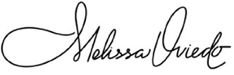
Melissa Oviedo
Chief Executive Officer
Themed Entertainment Association
303 N Glenoaks Blvd.
Burbank, CA 91502
melissa@teaconnect.org
+1 (407) 491-5172

